MIRAI TECHNOLOGIES / LEARN-IT
Product Overview & Selling Points
Customer-facing messaging for the Learn-It training and enablement platform
FROM COMPLETION TO READINESS
Turn approved company knowledge into structured learning, grounded assessment, and realistic AI-powered practice.
Visit MirAI | Request a Learn-It Demo

MirAI Technologies | September 2026

PRODUCT POSITIONING

What Learn-It is
Learn-It is an AI-powered training and enablement platform from MirAI Technologies that brings learning delivery, assessment, administration, and realistic AI-powered practice into one connected experience.
The positioning to lead with
Traditional training can tell you who completed a course. Learn-It is designed to help organizations move toward a more important question: can the learner actually apply what they learned?

Your company already has the knowledge. Learn-It turns it into capability.
SALES MESSAGING

Selling points
Use these as modular talking points in proposals, one-pagers, web copy, outbound messages, and discovery conversations.
• Turn existing company knowledge into training. Use approved policies, procedures, product documentation, sales guides, support content, presentations, and existing course material as the foundation for role-based learning.
• Build structured, editable courses. Organize knowledge into courses and modules with learning objectives, summaries, lesson content, assignments, and role-specific paths.
• Use AI to accelerate drafting - not replace subject-matter review. Learn-It can assist course and assessment creation while customer administrators and subject-matter experts review, edit, and publish what learners receive.
• Assess what was actually taught. Ground assessments in saved course modules so knowledge checks reflect approved training instead of a generic test bank.
• Support mastery instead of one-and-done testing. Use passing requirements, structured results, and retakes to give learners a path to demonstrate understanding.
• Practice realistic conversations with AI personas. Create reusable personas with configurable roles, tone, directness, visual identity, voice, language, and level of difficulty.
• Make practice dynamic rather than scripted. Persona Call interactions respond to the learner's own answers, ask follow-up questions, introduce objections, and change direction during the conversation.
• Evaluate applied readiness. Use the full learner interaction to assess whether someone can explain, respond, and apply the course material in a realistic situation.
• Give people a safe place to practice. Employees, customers, partners, dealers, franchisees, and software users can rehearse high-stakes or unfamiliar situations before the real conversation matters.
• Reduce dependency on manager-led role-play. Create repeatable practice experiences that do not require a trainer or manager to conduct every simulation.
• Assign learning to the people who need it. Customer administrators can manage learners, groups, assignments, due dates, invitations, reminders, completion, and progress.
• Create branded learning environments. Each customer can operate in a tenant-branded workspace designed around its audience, content, and training program.
• Support internal and external learners. Use the platform for employees as well as customers, partners, dealers, franchisees, and other invited learners.
• Control access commercially. Plans, feature entitlements, seat-aware access, and persona availability support different commercial offerings and customer configurations.
• Package Learn-It as an academy around a software or service offering. Software and service companies can use Learn-It to teach the product, the surrounding business process, and the customer conversations that drive adoption.
• Make progress visible. Administrators can see completion and learner progress instead of relying only on attendance or course publication.
DIFFERENTIATION

Why the story is stronger than 'another LMS'
The most defensible marketing message is not that Learn-It stores courses. It is that Learn-It connects approved knowledge, assessment, realistic practice, and administration so organizations can move from course completion toward demonstrated readiness.
• Knowledge is grounded in the organization's approved material.
• Assessment is connected to the material learners were actually taught.
• AI Persona Calls add realistic practice that adapts to the learner instead of following a fixed role-play script.
• Customer administrators can assign, manage, and monitor training from the same platform.
• The same platform can serve internal employees and external audiences such as customers, partners, dealers, and software users.
• Tenant branding, commercial entitlements, seats, and feature controls support packaged customer Academy offerings.
WHO TO SELL TO

Best-fit buyers and sponsors
• Learning & Development / Training leaders
• Human Resources and People Operations
• Operations leaders with high-turnover or process-intensive teams
• Compliance, Safety, Risk, or Quality leaders
• Sales Enablement and Revenue Operations
• Customer Support / Contact Center leadership
• Customer Success and Customer Education
• Software and service companies building a customer or partner academy
• Franchise, dealer, reseller, or partner enablement leaders
See what Learn-It could look like for your organization.
Explore the platform, then request access to the guided Learn-It demo.
Website: www.mirai-tek.com Demo: Request a Learn-It Demo hello@mirai-tek.com
SCAN OR CLICK
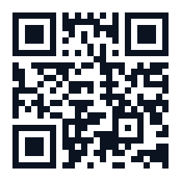  MirAI Technologies Website | 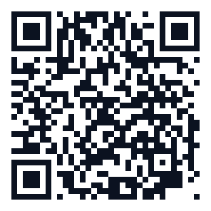  Request a Learn-It Demo

